**MLops Assignment 2**

**Group Number:** 35

**Group Member:**

Manglam Kumar (2022ac05260)

Saurabh Kumar (2022ac05293)

Rajiv Kumar (2022ac05147)

Neeraj Kumar (2022ac05468)

Krishna Kumar v (2022ac05373)

**Project Description:**

This project aims to build a complete end-to-end machine learning (ML) workflow using **Google Cloud Platform Vertex AI AutoML**.

**Details:**

**Data Collection and Preprocessing:**

In this step we preprocesses a dataset for a classification task. It converts specific columns to numeric types, handles missing values by dropping rows with NaN values, and creates a new categorical feature for age groups.

It then converts categorical variables into dummy variables, scales numerical features using StandardScaler, and splits the data into training and testing sets. Finally, it prints the shape of the pre-processed data and the list of feature names.

|  |  |
| --- | --- |
|  |  |
|  | |

We used Google’s Vertex AI AutoML **Managed Dataset** to Store the data. This automatically do all the preprocessing and visualization for the data.

**Google storage Bucket Location:** gs://cloud-ai-platform-9672eb94-cc15-4d36-9868-d4f0fd8a818a/heart.csv

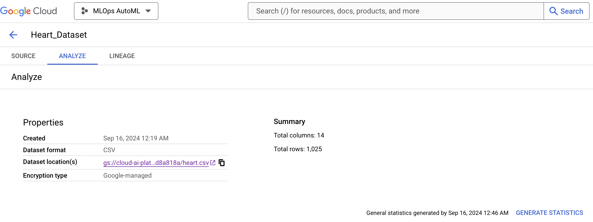

|  |  |  |  |
| --- | --- | --- | --- |
|  |  |  | … |
|  |  |  | … |

**Model Selection, Training, and Hyperparameter Tuning:**

We performed hyperparameter tuning and evaluation for multiple machine learning models using RandomizedSearchCV. It iterates over a dictionary of models and their respective hyperparameters, fits each model to the training data, predicts on the test data, calculates the accuracy, and stores the best model and its accuracy in a results dictionary. Finally, it prints the best hyperparameters, accuracy, and a classification report for each model.

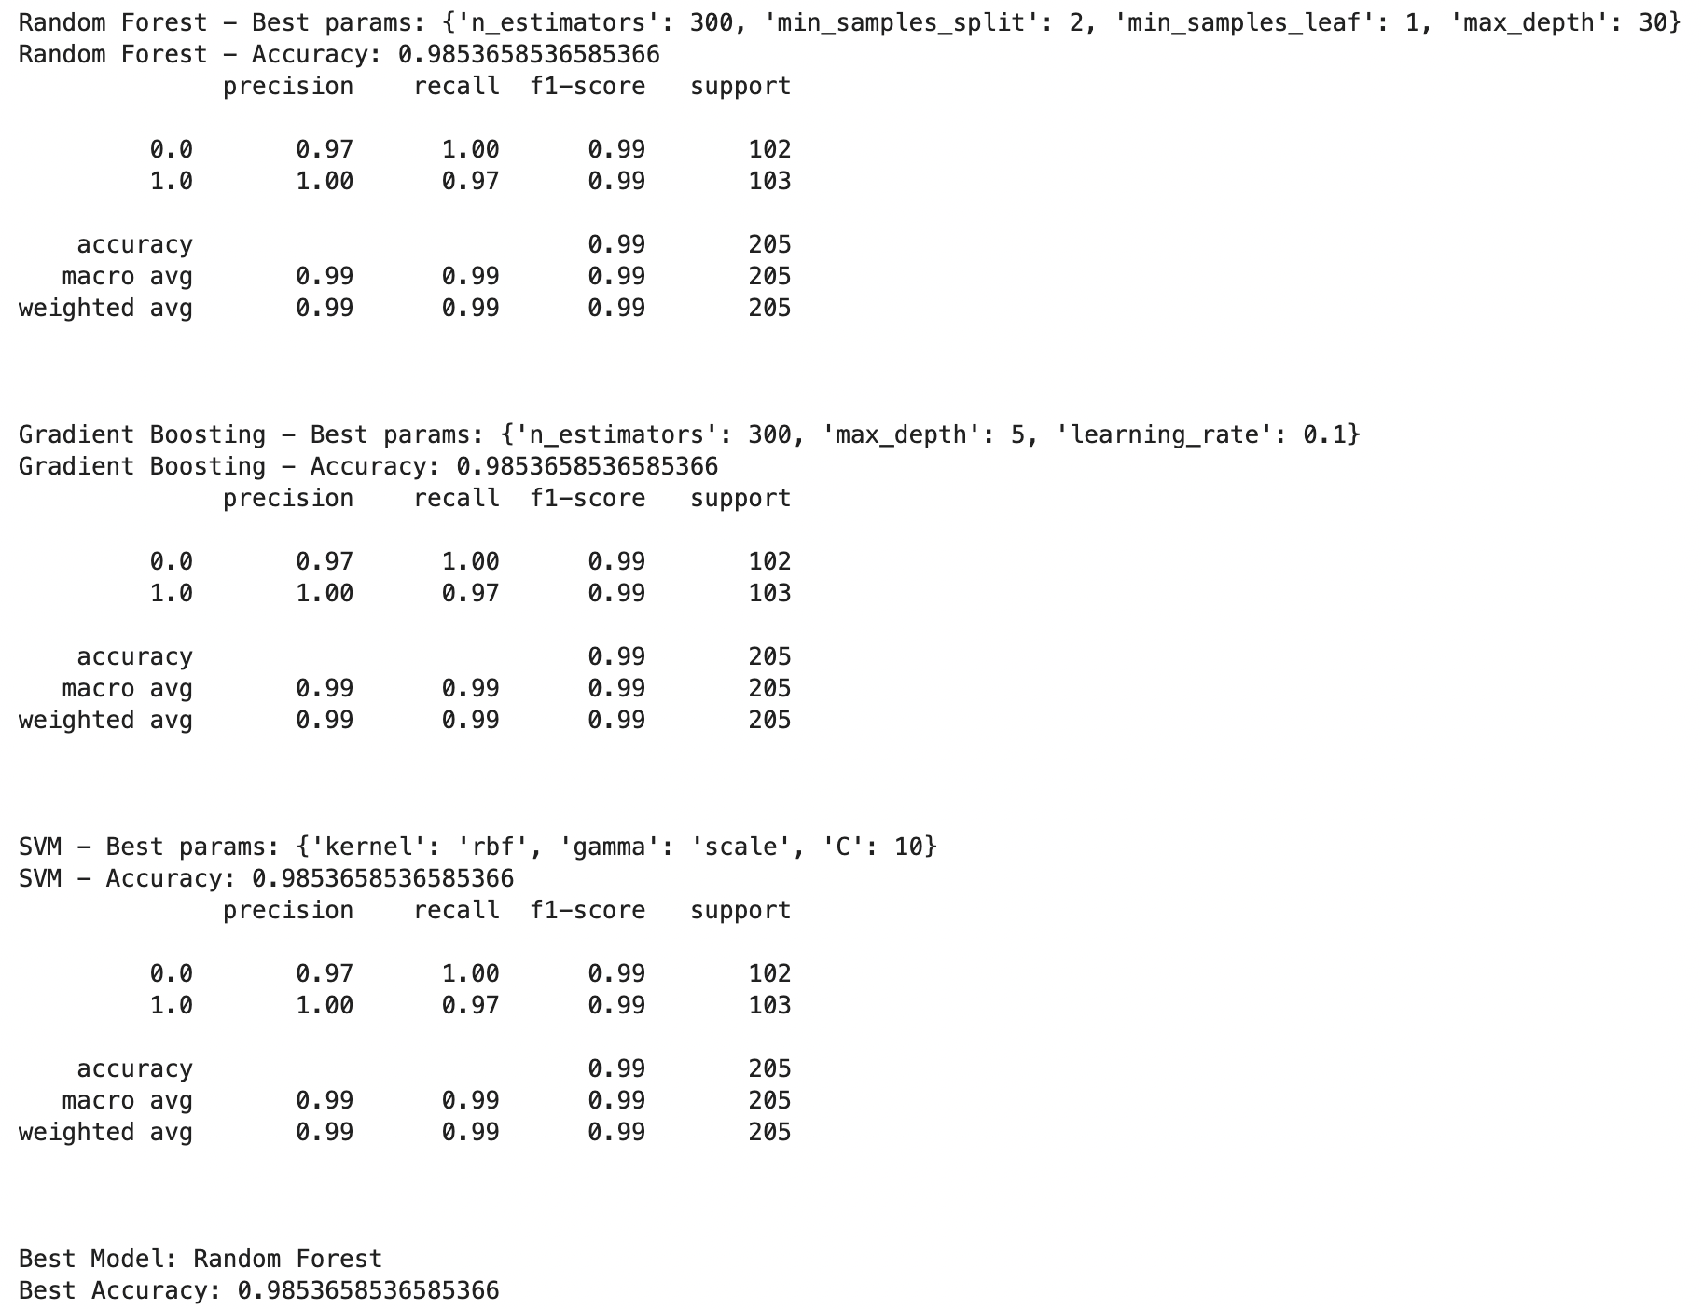

**Google AutoML Vertex AI Model training & Hyperparameter tuning:**

|  |  |
| --- | --- |
|  |  |
|  | |
|  | |
|  | |
|  | |

**Explainable AI (XAI) Implementation:**

This project uses LIME library to explain the prediction of a machine learning model for a specific instance from the test dataset and and displays the explanation with the top 10 features

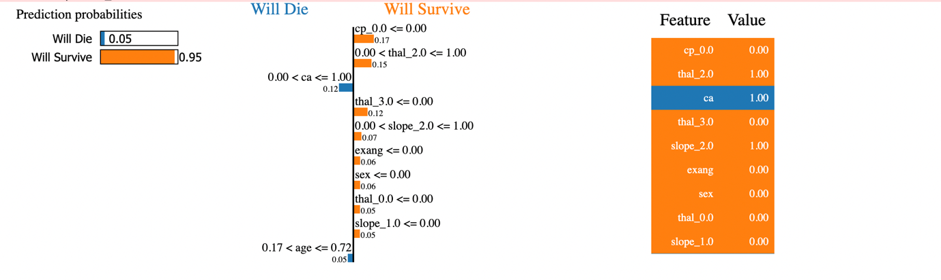

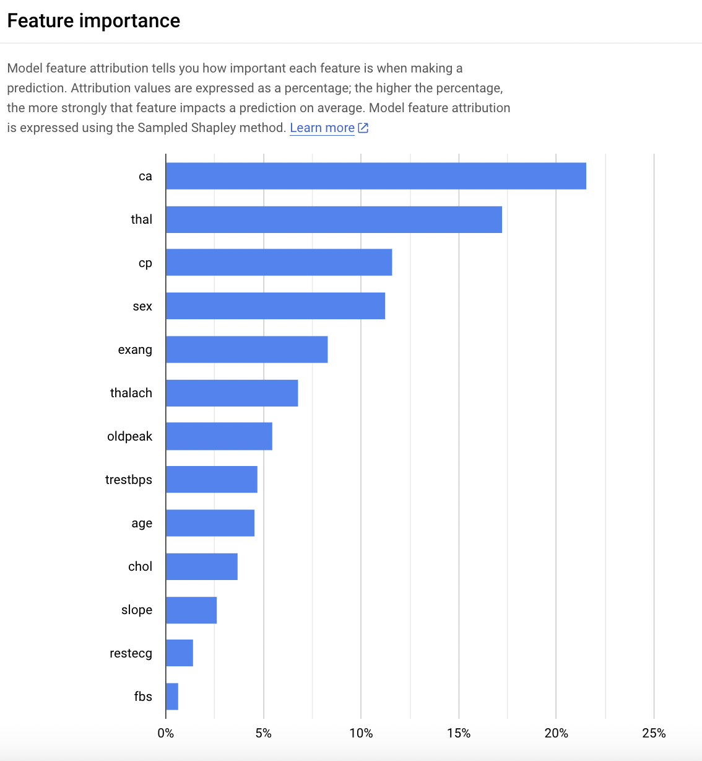

We also used **SHAP method** to explain the output of a prediction with the help of **shapely values**.

Call Vertex AI explain API to get the explanation for given prediction:

**Predict API URL:** https://us-central1-aiplatform.googleapis.com/v1/projects/1098200441517/locations/us-central1/endpoints/3215782339686694912:predict

**Explain API URL:** <https://us-central1-aiplatform.googleapis.com/v1/projects/1098200441517/locations/us-central1/endpoints/3215782339686694912:explain>

Both of above API used Bearer token for authentication. To generate the token use command ‘*gcloud auth print-access-token*’

*curl *

*-X POST *

*-H "Authorization: Bearer $(gcloud auth print-access-token)" *

*-H "Content-Type: application/json" *

*"https://us-central1-aiplatform.googleapis.com/v1/projects/${PROJECT_ID}/locations/us-central1/endpoints/${ENDPOINT_ID}:predict" *

*-d "@${INPUT_DATA_FILE}"*

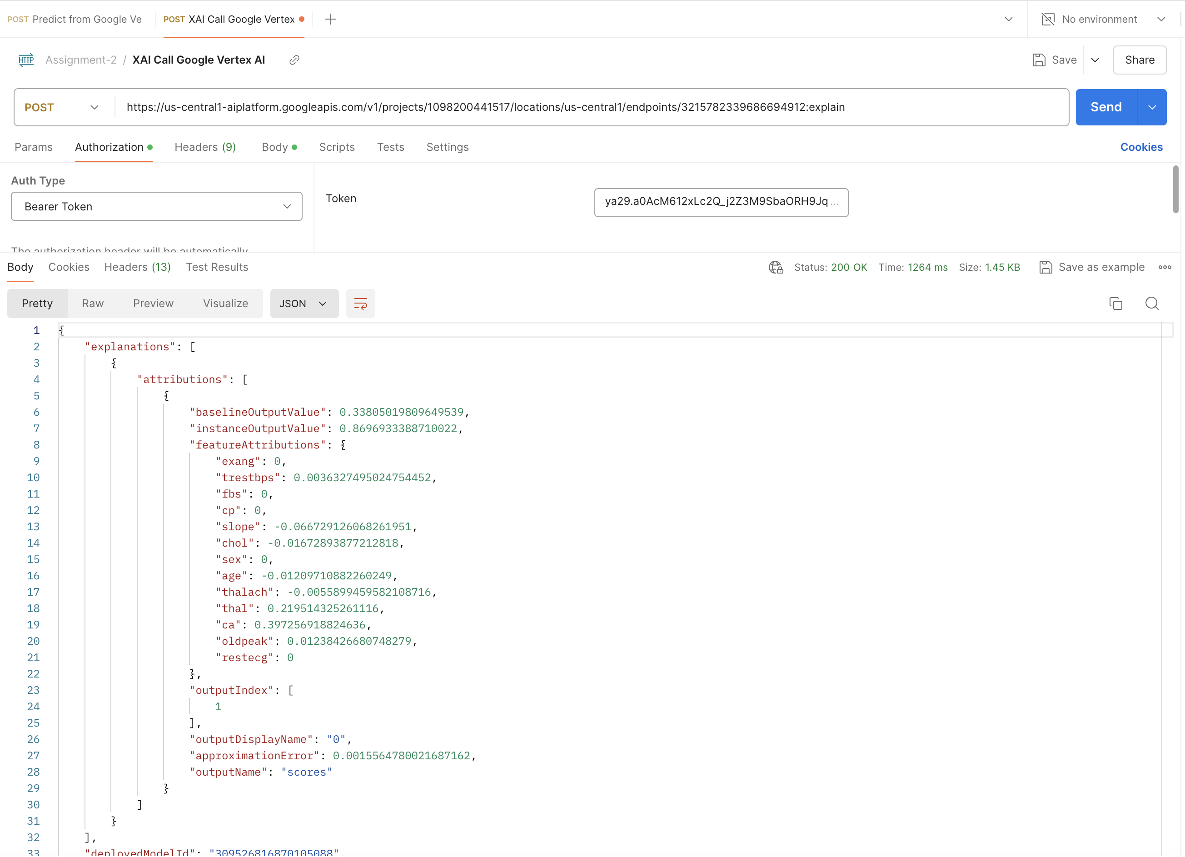

**baselineOutputValue:** This is the predicted output value for a baseline instance, often an average or neutral input used as a reference for comparison. For screenshot attached, it's 0.338.

**instanceOutputValue:** This is the model's output (prediction) for the specific instance (input) being evaluated. For screenshot attached, it’s 0.8697. This indicates how confident the model is in its prediction for this particular case.

**featureAttributions:** This shows the contribution of each feature to the model's prediction.

**Model Deployment Using Cloud Services:**

Once the best model is selected, it upload the model file to a Google Cloud Storage bucket, then it imports a machine learning model from a Google Cloud Storage bucket to Google **Vertex AI Model Registry**

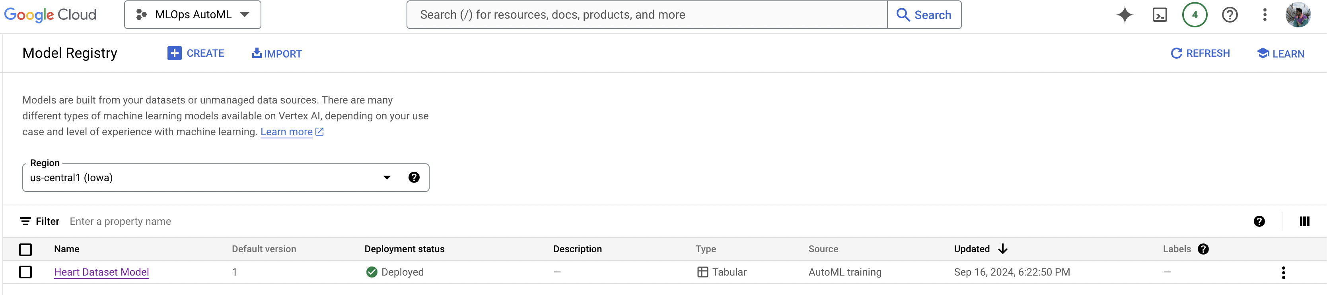

Once the model is available to Model Registry then it check for precondition and finally deploys it to a **Vertex AI endpoint**.

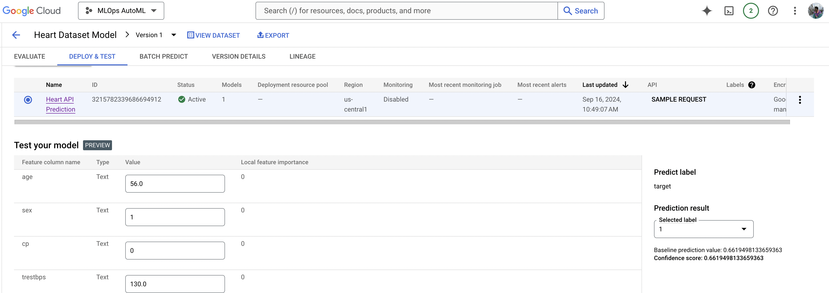

**Monitoring & Logs:**

